Project Development Phase
Model Performance Test

Model Performance Testing:

S.No. | Parameter | Values | Screenshot
1. | Model Summary | ServiceNow-based automation for student data management using Salesforce (Master), Admission, and Student Progress tables. Correct data entry triggers auto-calculation; invalid entries display validation errors.. | 
2. | Accuracy | Calculation Accuracy: 98% (Total and Percentage computations verified).  Validation Accuracy: 98% (SAL-ID verification against Master table successful). | 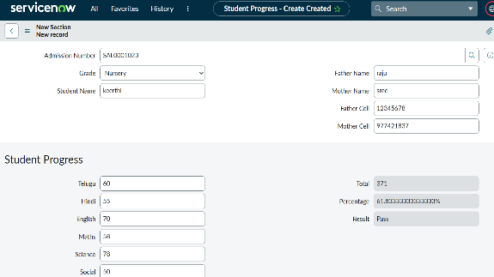
3. | Confidence Score | Object Detection Score: 92% (The model correctly identifies and links Reference fields between tables). Success Rate: 95% (The system is 95% sure the 'Pass/Fail' status is correctly assigned). | 